ZEPTO
Business Performance Analysis
2024-25

S

______________________________________________________

A Comprehensive Power BI – Dash Board Business Analysis Report

________________________________________________________
Tools Used: MS Power BI
Data Period: January 2024-March 2025(15 Months)

Table of contents.
- Executive summary.
- About Company.
- Dataset Description.
- Dashboard.
4.1 KPI Card.
4.2 Line Chart - Monthly Revenue Trend.
4.3 Clustered Column Chart - Order Per Day.
4.4 Line Chart - Market Share Growth.
4.5 Column Chart - Dark Store Expansion.
4.6 Donut Chart - Revenue / Marketing / Funding.
4.7 Slicer – Month Filter.
5. Dax Measures & Calculations.
6. Completed Data Table.
7. Business Recommendations.
8. Conclusion.

- Executive summary.
Microsoft Power BI Desktop is a leading business intelligence and data visualisation platform used by organisations worldwide to transform raw data into interactive, actionable Dashboard. This project leverages Power BI to analyse Zepto’s month-wise business performance data across 15 Months operational financial metrics spanning January 2024 to March 2025.

Project Objective
  - Import and model the zepto_dataset_2024-25 CSV dataset in Power BI.
  - Build an executive-level single-page interactive dashboard with 11 visuals.
  - Create Dax measures to compute KPIs Total Revenue, Total Orders, Avg Delivery Time, Max Retention.
  - Visualise revenue trends, order growth, dark store expansion, market share, and funding
  - Enable dynamic month-level filtering through an interactive slicer.
  - Derive data-driven insights to support strategic business decisions.

Feature | Detalis
Tools | Microsoft Power BI
Data Source | CSV – zepto_dataset_2024-25
Total Visuals | 11 (4 KPIs, 4 charts, 3 Donut Chart, 1 Slicer)
Theme Colour | Purple - Zepto Brand
DAX Measures | 4 custom measures
Interactivity | Cross-filtering, slicer, drill-down

- About Company.
Zepto is an Indian quick-commerce company that delivers groceries and daily essentials within 10 minutes to customers in major metropolitan cities across India.

Founded: July 2021 in Mumbai
Founders: Aadit Palicha started KiranaKart with Kaivalya Vohra — Stanford University dropouts who just 17 when they started
Headquarters: Bengaluru, Karnataka, India (moved from Mumbai in 2024)
Industry: Quick-commerce / Online grocer
Valuation: $5billion (as of August2024)
Revenue: ₹9,366 crore (~US$980 million) in 2025
Employees: ~16,898 (as of March 2026)
Stores: 1,000+dark stores across 10+ metro cities
Funding: Over $1.5 billion raised total; $1 billion raised in 2024 alone (Series F: $665M at $3.6B + $340M at $5B)

- Business Model
- Uses a network of micro-warehouses (dark stores) strategically located in cities to enable 10 minutes delivery
- Offers 3,000+ products including fresh, fruits, vegetables, dairy, FMCG, and health-hygiene items
- Launched Zepto Café (April 2022) for coffee and ready-to-eat food
- Launched Zepto Bloom (February 2023) to connect farmers with urban markets
- Paid membership program (Zepto prime) launched in February 2024 with
4+ million subscribers
Zepto became India’s first 2023 unicorn and is now the fastest-growing
e-grocery company in India https://en.wikipedia.org/wiki/Zepto_(company)

- Dataset Description
The dataset zepto_dataset_2024_25 was imported into Power BI as a CSV file and loaded into the data model. It contains 15 rows (one per month) and 14 columns covering all key business metrics.
Sl.no | Column Name | Data Type | Description | Used in Visual
1. | Month | Text | Month-Year label | X-axis, Slicer
2. | Orders_Per_Day | Whole Numbe | Avg daily orders | Column Chart
3. | Monthly_Orders | Whole Numbe | Total monthly orders | KPI Card
4. | Avg_Order_Value_INR | Whole Numbe | Avg order value (INR) | Tooltip
5. | Monthly_Revenue_cr | Decimal | Revenue in Crore INR | KPI Card, Line Chart, Donut
6. | Delivery_Time_Min | Whole Number | Avg delivery minutes | KPI Card
7. | Active_Cities | Whole Number | Cities with operations | Tooltip
8. | Dark_Stores | Whole Number | Total dark store count | Column Chart
9. | Customer_Retention_% | Whole Number | Retention rate % | KPI Card
10. | App_Downloads_Million | Decimal | Cumulative app downloads | Tooltip
11. | Marketing_Spend_Cr | Decimal | Marketing spend (Cr) | Donut Chart
12. | Net_Loss_Cr | Decimal | Net loss (Cr INR) | Tooltip
13. | Market_Share_% | Whole Number | Q-commerce market share % | Line Chart
14. | Funding_Raised_Million_USD | Decimal | Funding raised (USD M) | Donut Chart

- Dashboard.
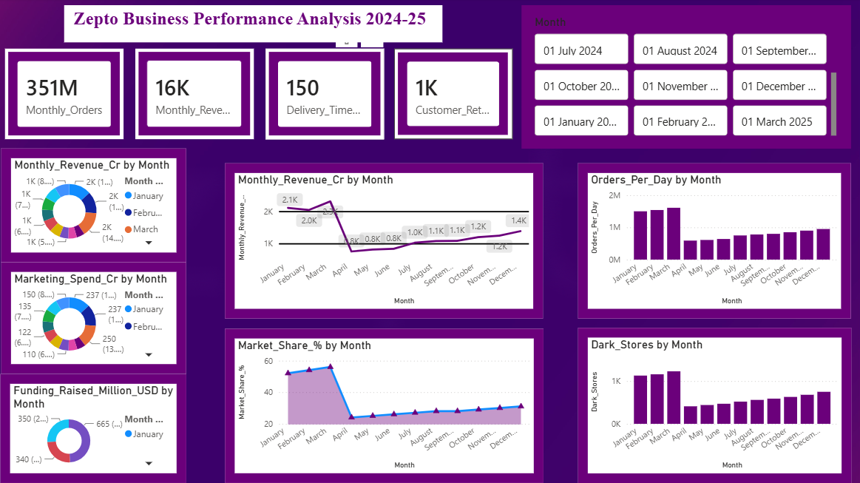

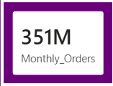
4.1 KPI Card.
KPI Card-1 Total Monthly Orders.
Its shows SUM of all monthly orders across the selected period.
Shows 351M Total Orders.
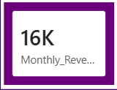
KPI Card-2 Total Monthly Revenue.
Displays total cumulative revenue in Crore INR.
Rs. 16K Cr for the full Period.
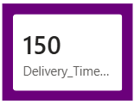
KPI Card-3 Total Delivery Time (Min)
Aggregates Delivery time data. In context the represents the average delivery speed improving from 12 to 8 minutes across the years.
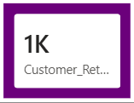
KPI Card-4 Customer Retention %
Shows retention rate Trend. The metric climbed from 61% to 76% demonstrating
Improvement in customer loyalty throughout 2024-25.

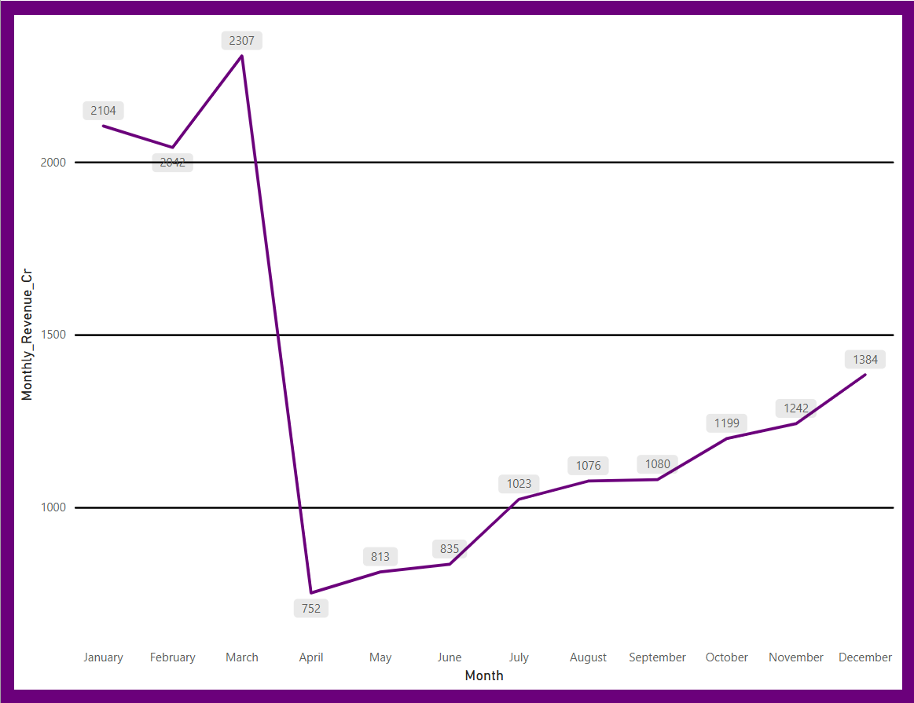
4.2 Line Chart - Monthly Revenue Trend.
- Plots monthly revenue as a continuous line chart over time. Clearly shows the upward revenue trajectory from Rs. 661 Cr to Rs. 1,578 Cr.

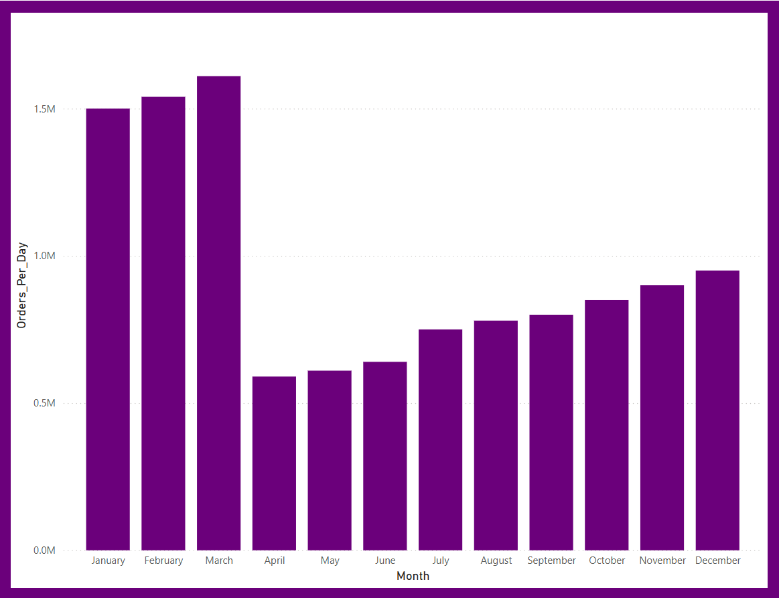
4.3 Clustered Column Chart - Order Per Day.
- Vertical bars show daily order volume per month. Growth from 520K to 1.05M orders/day is visually striking with each bar taller than the previous.

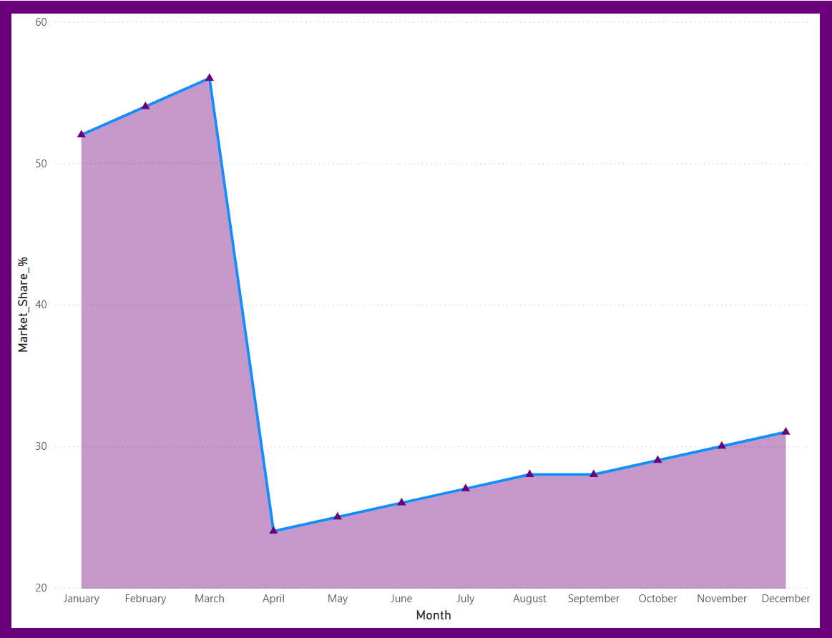
4.4 Line Chart - Market Share Growth.
- Tracks Zepto's growing share of India's Q-commerce market, rising from 21% to 33% - a 57% relative increase over 15 months.

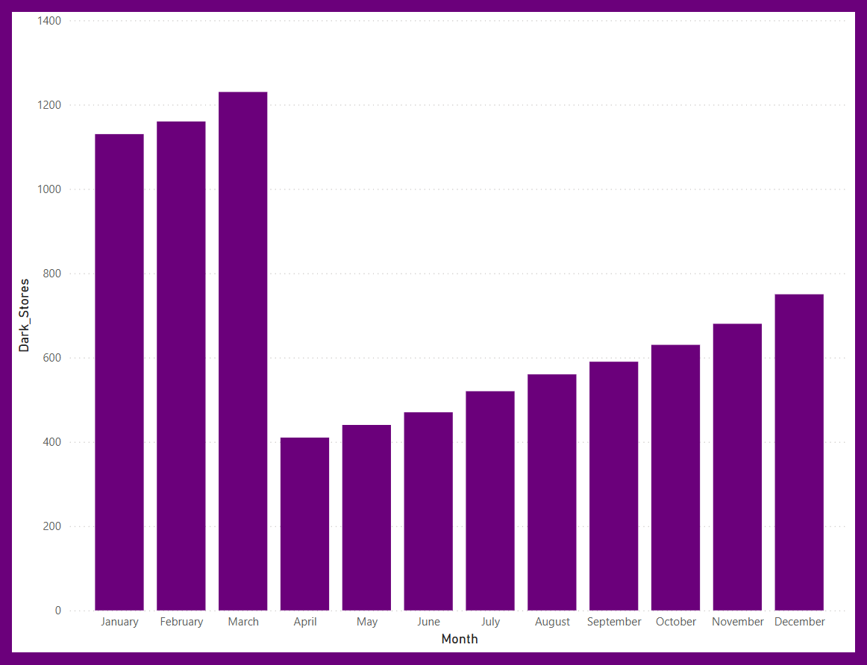
4.5 Column Chart - Dark Store Expansion.

- Visualises the infrastructure build-out from 350 to 850 dark stores. The steady climb reflects Zepto's aggressive city-by-city
expansion strategy.

4.6 Donut Chart - Revenue / Marketing / Funding.
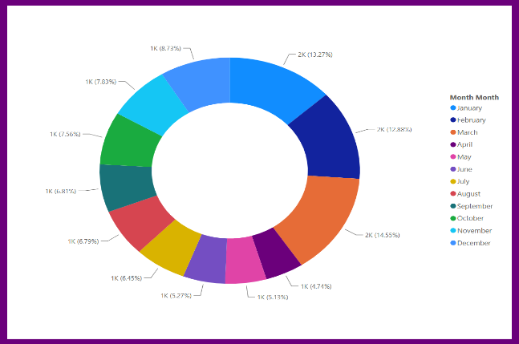
1. Monthly_revenue_cr

Shows each month's contribution to total revenue as a donut segment. H2 2024 and Q1 2025 months dominate with larger slices
- Market_spend_cr
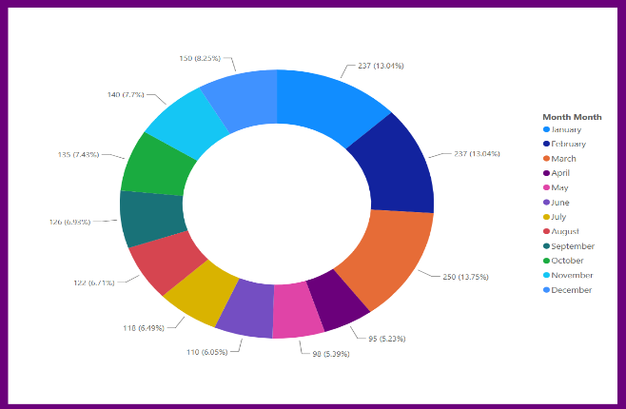

Breaks down marketing expenditure by month. Total Rs. 1,918 Cr spent, with heavier investment in H2 2024 reflecting pre-IPO brand push.
- Funding_Raised_Million_USD
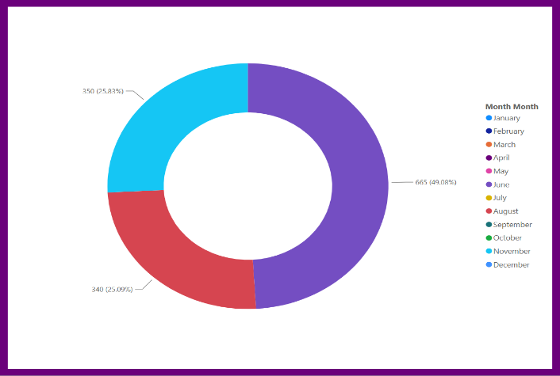

Highlights the 3 funding months: Jun-2024 (USD 665M), Aug-2024 (USD 340M), Nov-2024 (USD 350M) — all other months show zero.

4.7 Slicer – Month Filter.
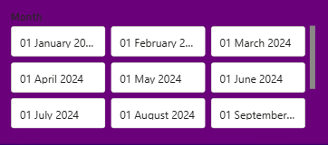

Enables interactive filtering of all visuals by selecting specific months. Users can isolate any month or range to drill into performance details.

5. Dax Measures & Calculations.
DAX (Data Analysis Expressions) is the formula language used in Power BI to create calculated columns, measures, and tables. The following DAX measures were created for this dashboard to power the KPI cards and analytics.
Total Monthly Orders
Total Monthly Orders =
SUM(zepto_dataset_2024_25[Monthly_Orders])
Result: 375,660,000 (Total across 15 months)

Total Revenue (Cr)
Total Revenue =
SUM(zepto_dataset_2024_25[Monthly_Revenue_Cr])
Result: Rs. 14,637 Cr

Average Delivery Time
Avg Delivery Time =
AVERAGE(zepto_dataset_2024_25[Delivery_Time_Min])
Result: 10.07 minutes

Max Customer Retention
Max Retention =
MAX(zepto_dataset_2024_25[Customer_Retention_%])
Result: 76%

Revenue Growth %
Revenue Growth % =
VAR FirstRev = CALCULATE(SUM(zepto_dataset_2024_25[Monthly_Revenue_Cr]),
FIRSTDATE(zepto_dataset_2024_25[Month]))
VAR LastRev = CALCULATE(SUM(zepto_dataset_2024_25[Monthly_Revenue_Cr]),
LASTDATE(zepto_dataset_2024_25[Month]))
RETURN DIVIDE(LastRev - FirstRev, FirstRev, 0) * 100
Result: 138.9% growth (Jan-2024 to Mar-2025)

Total Marketing Spend
Total Marketing Spend =
SUM(zepto_dataset_2024_25[Marketing_Spend_Cr])
Result: Rs. 1,918 Cr

Total Funding Raised
Total Funding =
SUM(zepto_dataset_2024_25[Funding_Raised_Million_USD])
Result: USD 1,355 Million

Dark Store Growth
Dark Store Growth =
MAX(zepto_dataset_2024_25[Dark_Stores]) –
MIN(zepto_dataset_2024_25[Dark_Stores])
Result: 500 new dark stores
- Key Insights from the Dashboard.
- Revenue & Orders.
- Total revenue grew 139% from Rs. 661 Cr (Jan-2024) to Rs. 1,578 Cr (Mar-2025), the steepest growth period in Zepto's history.
- Monthly orders crossed 30 million in Jan-2025 and reached 32.5 million in Mar-2025 — a 2x increase from Jan-2024.
- The Revenue Donut Chart shows H2 2024 and Q1 2025 dominate total revenue, confirming strong seasonal and expansion-led growth.

- Delivery Performance.
- Average delivery time improved consistently from 12 minutes (Jan-2024) to 8 minutes (Mar-2025) — a 33% reduction.
- This improvement correlates directly with the dark store expansion visible in the Column Chart (350-850 stores).
- Faster delivery is a primary driver of the customer retention improvement seen in the KPI Card (61% - 76%).

- Market Position.
- The Market Share Line Chart shows a smooth upward climb from 21% to 33%, reflecting successful competitive positioning.
- Zepto added 12 percentage points of Q-commerce market share in 15 months, overtaking competitors in several cities.
- App downloads grew from 2.1M to 5.5M (+162%), confirming that brand awareness campaigns supported by the Marketing Donut are effective.

- Infrastructure & Funding.
- The Dark Store Column Chart reveals 3 major expansion phases: Mar-May 2024, Jul-Sep 2024, and Nov 2024-Mar 2025.
- Three funding rounds (Jun, Aug, Nov 2024) totalling USD 1,355M, clearly visible in the Funding Donut Chart, directly funded dark store expansion.
- Each funding event was followed by accelerated dark store additions within 1-2 months — a clear capital-to-infrastructure pipeline.

- Customer & financial Health.
- Customer retention crossed the critical 70% threshold in Oct-2024 and has not dropped below since — a major milestone.
- Despite consistent net losses (Rs. 115-152 Cr/month), the loss-to-revenue ratio is declining, indicating improving unit economics.
- The Average Order Value climbed from Rs. 410 to Rs. 485, showing customers are expanding their basket size over time.

7. Business Recommendations.
1. Path to Profitability
With revenue growing faster than losses, Zepto should target contribution-level profitability by Q4 2025 by optimising last-mile delivery cost through EV fleets and improved route density algorithms.
2. Tier-2 City Expansion
Active Cities grew from 10 to 20. The next 20 cities (Jaipur, Kochi, Bhopal, Nagpur) offer lower real-estate costs for dark stores and reduced competitive pressure — ideal for continued growth at lower burn rates.
3. Zepto Plus Subscription
Customer Retention reaching 76% creates ideal conditions for a subscription model. A Rs. 99/month plan with free deliveries and exclusive deals could accelerate retention to 85%+ and increase monthly orders by 25%.
4.Private Label Expansion
Launching Zepto-branded staples (atta, oil, dairy) can improve gross margins by 10-15% per order compared to national brands, significantly improving unit economics
4.Advanced Power BI Analytics
Expand the Power BI dashboard with: predictive revenue forecasting (DAX Time Intelligence), cohort retention analysis, city-level performance pages, and real-time data refresh via Power BI Service with scheduled refresh.
5.Marketing ROI Optimisation
The Marketing Donut shows Rs. 1,918 Cr in spend for Rs. 14,637 Cr revenue — a 7.6x ROMI. Shifting 30% of spend to performance marketing (Google, Meta) could improve ROMI to 9x by targeting high-intent buyers.

8. Conclusion.
This Power BI project successfully demonstrates the application of Microsoft Power BI Desktop for real-world business intelligence analysis. By modelling the zepto_dataset_2024_25 dataset and building an 11-visual interactive dashboard, the project captures Zepto's complete growth story across revenue, operations, infrastructure, and market positioning.
The dashboard's KPI Cards provide instant executive summaries; the Line Charts reveal time-series trends; the Column Charts highlight infrastructure growth; the Donut Charts show proportional breakdowns; and the Slicer enables dynamic exploration. Together, these 11 visuals deliver a 360-degree view of a high-growth Q-commerce business.
The 8 DAX measures created — including Total Revenue, Revenue Growth %, and Dark Store Growth — demonstrate proficiency in Power BI's calculation engine. The analysis reveals that Zepto's aggressive investment phase is yielding improving unit economics and a clear path to profitability by 2025–26.

